**PBCC: Accomplishments 2019/2020, 2020 Meeting, and goals for 2020/2021**

**2019/2020 PBCC Accomplishments:**

* Completion and publication of the U.S. public sector breeding capacity survey, in partnership with NIFA NRSP10 and NSF PGRP projects (PI: Dorrie Main) and Michael Coe (Cedar Lake Research Group), and National Association of Plant Breeders (NAPB). “Coe, MT, Evans, KM, Gasic, K, Main, D. 2020. Plant Breeding Capacity in US Public Institutions. Crop Science. 60:2373–2385. DOI: 10.1002/csc2.20227.” National Association of Plant Breeders (NAPB) provided $1,000 for open access fees.
* The survey publication had the highest public visibility for a Crop Science paper in the last decade, and was among the top 5% of papers in 2020. Currently, 366 breeding programs are registered on the NRSP10 map (<https://www.nrsp10.org/pbcc-survey-geomap>). The number of breeding programs represents the number of different crops being bred rather than actual programs since many breeders are involved in breeding more than one crop.
* Publication of the survey of Germplasm Curator training capacity “Volk, GM, Bretting, PK, Byrne, PF. (2019). Survey identifies essential plant genetic resources training program components. Crop Science, 59(6), 2308-2316.” NAPB provided $1,000 for Open Access fees.
* The proposal ‘Enhancing Educational Outcomes for Plant Genetic Resources Conservation and Use’ was submitted and approved for funding by the USDA-NIFA Higher Education Challenge Grant The objective was approved program to develop online courses and training materials on plant genetic resources
* Volk, GM, and Byrne, PF. 2020. Crop Wild Relatives and Their Use in Plant Breeding. Public

domain eBook (<https://colostate.pressbooks.pub/cropwildrelatives/>) was completed.

* Completion of Infographics on plant genetic resources conservation and use was contracted with artist Leah Kucera. NAPB provided $2,000 for this initiative (see appendix)
* Michael Kantar represented PBCC at the “The Discipline of Plant Breeding Symposium” held in Washington D.C. in February 2020, Funding of $1,700 was received from NAPB to support PBCC participatation.
* A team lead by Thomas Lubberstedt and consisting of Anthony Mahama and Michael Retallick (all at Iowa State University), Martin Bohn and Dorrie Main was created to write a white paper on plant breeding core outcomes/concepts/learning objectives for university plant breeding courses. The partnership includes NIFA NRSP10 and NSF PGRP projects (PI: Dorrie Main), and University of Illinois Urbana-Champaign (Martin Bohn).
* Additional best practices worksheets on plant breeding communication are available at <https://www.plantbreeding.org/files/napb/science-communication-for-plant-breeding-tips-combined.pdf>.
* Completed the renewal which was approved to continue the project for 2020-2025.

**Annual PBCC Meeting, Virtual, August 14, 2020**

**Goals for 2020/2021**

All five current objectives were addressed at the annual PBCC meeting within the ongoing SCC80 project. The annual meeting was held remotely on zoom, Thirty-seven reps were in attendance along with Ann Marie Thro (NIFA REP-emeritus) and Robert Gilbert (ADMIN ADV.). Paul Zankowski (Senior Advisor for Plant Health & Production and Plant Products, Office of the Chief Scientist), and NIFA representative Ann Stapleton (see appendix list).

Below are goals for each objective for the new 5-year project:

***Objective 1:*** *Collect, analyze, and disseminate information about the U.S. plant breeding effort in both public and private sectors, to include human capacity and access to enabling knowledge, technologies, germplasm, and infrastructure [Lead Dr. Kate Evans]*

* Re-issue the survey every 5 years to align the survey with governmental 5-year plans to be in sync with government funding. The first re-issue would be sooner (3 years after the initial survey, 2021) to include all programs that have been registered after the initial deadline, and therefore will not be included in the report/publication.
* Collate private sector breeding data from published annual reports.
* Develop private sector breeding survey.

***Objective 2****: Promote the conservation, characterization, and utilization of plant genetic resources and access to those resources for plant breeding. [Lead Dr. Pat Byrne]*

* Continue work on the funded USDA-NIFA Higher Education Challenge Grant.
* Develop a series of short instructional videos for genebank training using funding from USDA-NLGRP and PROCINORTE, a collaboration among the national germplasm systems of the U.S., Canada, and Mexico.
* Make regional data from germplasm committees available to all members.

***Objective 3****: Identify Best Management Practices for public sector intellectual property protection to encourage the creation and distribution of improved crops for a broad range of needs and opportunities. [Lead Dr. Bill Tracy]*

* Continue to provide outreach as opportunities arise.

***Objective 4****: Optimize opportunities for public-private collaboration in plant breeding research and education, including continuing education for plant breeders. [Lead Dr. Thomas Lubberstedt]*

* White paper creation.
* Development of higher education challenge grant.

**Objective 5.** *Foster communication among public plant breeders and federal agencies on public policy issues, including alerts to existing and emerging threats to agricultural security that are relevant to plant breeding. [Lead Drs. Mikey Kantar and Mike Gore]*

* Build on the communication materials developed to reach more students and continue to make all materials available to the plant breeding community and broader public.
* Establish dissemination of the information to the state representatives from the PBCC leadership, to ensure continuity which is especially important when the administrators change and are not from the agricultural background.

**Other goals:**

* Increase number of states represented in SSC80 and encourage participation by state reps in development of renewal objectives
* Continue to update and add content to PBCC webpages
* Create strategic plan with NAPB for improved alignment towards NAPB/PBCC common goals

**Appendix**

**Minutes for PBCC Annual PBCC Meeting, Virtual, August 14, 2020**

Opening Comments:

Introductions: Mikey Kantar, PBCC current Chair; Rich Pratt, incoming chair; Wayne Smith, incoming vice chair; Duke Pauli, incoming secretary, and Ksenija Gasic, past Chair. Full attendance list at the end of the document.

Overview:

Many people have been involved since the inception in 2005. We currently have 45/50 states represented, we are still missing Alaska, Idaho, Missouri, Connecticut, and Rhode Island. Currently we are in the last year of the 5-year project. We completed the strategic planning and the renewal document was approved with the new 5-year project beginning October 1, 2020. We have continued our agreement with NAPB to receive $6K per year for PBCC activities. These funds have been important for getting plant breeding representatives to events, manuscripts printing costs, and travel. We continue to encourage PBCC reps to become more involved in the project by participating and/or leading one or more objectives they find interesting. Activities are not limited to the executive committee.

MK represented PBCC at the “The Discipline of Plant Breeding Symposium” held in Washington D.C. in February 2020. MK introduced the agenda and current and past PBCC leadership. Welcome new administrative advisor Robert Gilbert and new NIFA representative Ann Stapleton is retiring from federal service.

MK presented brief history of the PBCC. He covered origin of multi-state projects (MSP), coordinating committees (CC) and the intended roles of these committees, provided few examples of current multistate projects and explained the similarities and difference between the multistate projects and coordinating committees. There was a quick overview of the Plant Breeding CC and accomplishments that lead into the new objectives for the 2020-2025 cycle. The new objectives were accepted and it was decided to have separate breakout meetings at another date for each objective subcommittee.

**Objective 1: Collect, analyze, and disseminate information about the U.S. plant breeding effort in both public and private sectors, to include human capacity and access to enabling knowledge, technologies, germplasm, and infrastructure.**

The public plant breeding program survey data published in Crop Science (see appendix). The article received a lot of attention from the popular press, in fact it received more media attention than any other Crop Science article in the last decade. The highlights of the study included; There have been significant reductions in personnel in plant breeding over last 5 years, program leaders are aging, there has been increasing budget shortfalls that have increased uncertainty endangering support of key personnel, decreased maintenance of core infrastructure & operations, and limiting the use of current technology. This has also decreased graduate and post-graduate training. There is a total of 366 programs that are searchable on the interactive U.S. map available at https://www.nrsp10.org/. The breeding programs are recorded by the crop since many breeders are working on more than one crop. The goal in the next 5-years is to repeat the survey to understand how things change over time. In the next cycle there is also a goal of trying to understand the capacity of the private sector, which will also explore the educational profile of the future workforce. A new method will be needed in order to maximize the amount of information that will be gathered that fills in gaps that are not already publically shared. There is potential to tie this into PBCC objective four to see what education private breeding companies are looking for in the future workforce. If you are interested in participating, contact KE, WS and or MBK.

**Objective 2: Promote the conservation, characterization, and utilization of plant genetic resources and access to those resources for plant breeding.**

Several major accomplishments were completed under this objective: (1) Completion of infographics; (2) Completion of Ebook on CWR use in breeding <https://colostate.pressbooks.pub/cropwildrelatives/>, which was inspired by PBCC and made possible in part by funding from USDA-ARS, Colorado State University, IICA-PROCINORTE, and USAID; (3) Higher education challenge grant on “Enhancing Educational Outcomes For Plant Genetic Resources Conservation and Use” was awarded in June 2020. (4) a paper on the survey on Plant Genetic Resources Learning Materials published in Crop Science ‘Volk, G. M., Bretting, P. K., & Byrne, P. F. (2019). Survey identifies essential plant genetic resources training program components. Crop Science, 59(6), 2308-2316’. The use of these different materials is going to be tracked. Given the number of activities. There is a desire to increase the size of the team working on this objective.

**Objective 3: Identify Best Management Practices for public sector intellectual property protection to encourage the creation and distribution of improved crops for a broad range of needs and opportunities.**

Outcome of this objective, Intellectual Property Rights (IPR practices) have been found useful for Land Grant Universities in developing their own IPR policy. Even though there was no major activity in this objective in the past year, Bill Tracy has continued to work on IPR and communicating IPR issues to tech transfer professionals and tech transfer officers (https://agronomy.wisc.edu/ipr-summit/.

**Objective 4: Optimize opportunities for public-private collaboration in plant breeding research and education, including continuing education for plant breeders.**

The current focus is working on a common core for plant breeding that can be transferred across institutions. This has been done in the context of developed online degree programs and comparing the skills gained to what is expected in both the public and private sectors. This is also the case with respect to international constraints. This pedagogy work has been done in collaboration with education researchers as well. This leads to common standards and language regarding what students should know and what results in a professional career when they graduate from a program. This year work was done to develop core outcome/concept/learning objective lists generated for all Iowa State University (ISU) plant breeding courses, this was furthered by doing “course pairing” to identify gaps and redundancies to comply with Bloom’s taxonomy. The hierarchical web-tool for MS PLBR core concept/outcomes/learning objectives was made public after feedback from ISU and other institutions was received. Following similar idea as presented in Objective 2 for Plant Genetic Resources education. The next steps are to develop web-based system to enable regular discussions in the plant breeding community, and to identify what are core concepts for graduate level education. This tool could be further developed to incorporate tests, quizzes or similar, to determine which competencies are mastered by students. The goals for next year are to develop a white paper and to develop a higher education challenge grant to ensure the future of plant breeding capacity.

**Objective 5: Foster communication among public plant breeders and federal agencies on public policy issues, including alerts to existing and emerging threats to agricultural security that are relevant to plant breeding.**

The communication objective has progressed this year. The Cornell Alliance for Science material from the Science communication workshop for Plant science (<http://news.cornell.edu/stories/2018/07/workshop-trains-plant-scientists-communicate-science>) held few years ago is available upon request. Science art collaboration was established has made all of the infographic products created available. Templates on how to write the blog, do an interview etc. are downloadable from the NAPB website as well as the best practices worksheets (<https://www.plantbreeding.org/files/napb/science-communication-for-plant-breeding-tips-combined.pdf>).

There is still a need to be a better dissemination of the information to the state representatives from the PBCC leadership. It is especially important when the administrators change and are not from the agricultural background.

**Renewal**

The renewal document was approved and it was disseminated to all of the PBCC membership and to the experiment stations.

**Infographics on plant genetic resources that were developed**

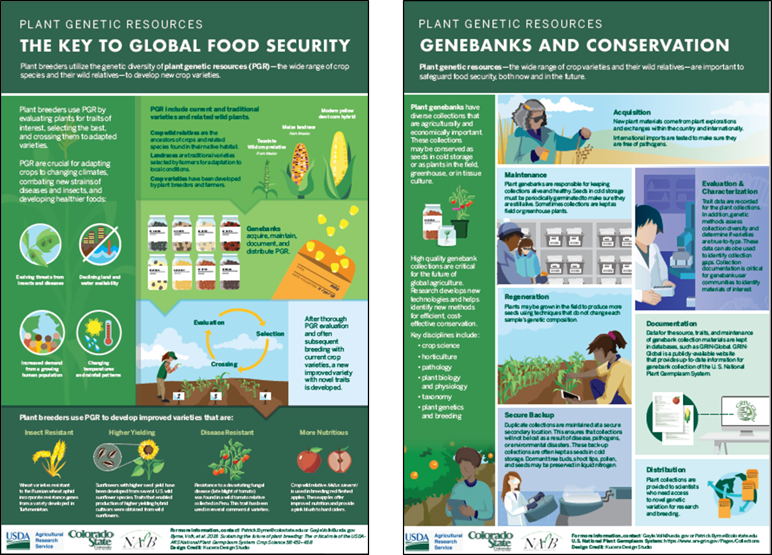

**Attendees 2020**

|  |  |  |
| --- | --- | --- |
| Moldenhauer, Karen K. | kmolden@uark.edu | Arkansas - University of Arkansas |
| Byrne, Patrick F | patrick.byrne@colostate.edu | Colorado - Colorado State University |
| Kalpalatha, Melmaiee | kmelmaiee@desu.edu | Delaware State University |
| Resende, Marcio | mresende@ufl.edu | Florida - University of Florida |
| Missaoui, Ali M | cssamm@uga.edu | Georgia - University of Georgia |
| Kantar, Michael | mbkantar@hawaii.edu | Hawaii - University of Hawaii |
| Bohn, Martin | mbohn@uiuc.edu | Illinois - University of Illinois |
| Lubberstedt, Thomas | thomasl@iastate.edu | Iowa - Iowa State University |
| Myers, Gerald | gmyers@agctr.lsu.edu | Louisiana - Louisiana State University |
| Tan, Ek Han | ekhtan@maine.edu | Maine - University of Maine |
| Iezzoni, Amy | iezzoni@msu.edu | Michigan - Michigan State University |
| Anderson, Neil | ander044@umn.edu | Minnesota - University of Minnesota |
| Wallace, Ted | twallace@pss.msstate.edu | Mississippi - Mississippi State University |
| Sherman, Jamie | jsherman@montana.edu | Montana - Montana State University |
| Graef, George | ggraef1@unl.edu | Nebraska - University of Nebraska |
| Baenziger, P. Stephen | pbaenziger1@unl.edu | Nebraska - University of Nebraska |
| Barrios Masias, Felipe | fbarrios@cabnr.unr.edu | Nevada - University of Nevada |
| Hale, Iago L | iago.hale@unh.edu | New Hampshire - University of New Hampshire |
| Pratt, Richard | ricpratt@ad.nmsu.edu | New Mexico - New Mexico State University |
| Smith, Margaret E. | mes25@cornell.edu | New York -Ithaca : Cornell University |
| Rahman, Mukhlesur | md.m.rahman@ndsu.edu | North Dakota - North Dakota State University |
| Francis, David M. | francis.77@osu.edu | Ohio - Ohio State University |
| Wu, Yanqi | yanqi.wu@okstate.edu | Oklahoma - Oklahoma State University |
| Foolad, Majid | mrf5@psu.edu | Pennsylvania - Pennsylvania State |
| Gasic, Ksenija | kgasic@clemson.edu | South Carolina - Clemson University |
| Sehgal, Sunish | sunish.sehgal@sdstate.edu | South Dakota - South Dakota State University |
| Leckie, Brian | bleckie@tntech.edu | Tennessee Tech University |
| Smith, C. Wayne | cwsmith@tamu.edu | Texas AgriLife Research |
| Egnin, Marceline | megnin@tuskegee.edu | Tuskegee University |
| Moyers, Brook | brook.moyers@umb.edu | University of Massachusetts/Boston |
| McCord, Per | phmccord@wsu.edu | Washington - Washington State University |
| Evans, Kate M | kate_evans@wsu.edu | Washington - Washington State University |
| Liedl, Barbara E. | liedlbe@wvstateu.edu | West Virginia State University |
| Tracy, William | wftracy@wisc.edu | Wisconsin - University of Wisconsin |
| Bonos, Stacy A | bonos@sebs.rutgers.edu | New Jersey - Rutgers University |
| Zankowski Paul | [paul.zankowski@usda.gov](mailto:paul.zankowski@usda.gov) | USDA-OCS |
| Thro Ann Marie | [AnnMarie.Thro@usda.gov](mailto:AnnMarie.Thro@usda.gov) | NIFA |
| Stapleton, Ann | Ann.Stapleton@usda.gov | NIFA |
| Gilbert, Robert | ragilber@ufl.edu | UF |